**Health promotion and maintenance**

**Definition:**

Health promotion is the process of enabling people to increase control over, and to improve their health.

(WHO,1986)

Health promotion refers to activities that increase the well being and enhance wellness or health.

(Pender, Murdaugh and parsons,2006).

It is the process which empowers families and communities to improve their quality of life, achieve and maintain health and wellness. It emphasizes not only prevention of disease, but the promotion of positive good health.

* **Health promotion activities**

1.Immunization

1. Safety and accident prevention

3.Screening

4.Counselling

5.Lifestyle changes.

6.Stress management and adoptive mechanism.

7. Hormone Replacement therapy

**COUNSELLING**

**Definition**

* The counseling is an artful application of scientifically derived psychological knowledge and techniques for the purpose of changing human behavior.
* Counseling is ‘therapeutic communication’
* Counseling develops positive attitudes.
* Counseling is different from advising.
* It requires communication skills, relationship skills, analytic skills and motivation skills.

-The positive changes in the counselee may be :

* Cognitive

 - Changing how a person thinks

* Affective

- Changing how a person feels

* Behavioral

-Changing how a person behaves or acts

**Aims of counseling**

* It help people to gain an insight .
* To improve communication and interpersonal skill
* To make able to change self defective behaviour .
* To relive from depression and other mental health condition.
* To increase confident and decision making skill.

**Steps of' ‘GATHER' techniques are used in effective counseling**

* Greet: Greet the patient .
* Ask: Ask the patient about his problem.
* Tell: Tell him about the available solutions / options.
* Help: Help in selecting the solutions / options.
* Explain: Explain the consequences and the selected solution .
* Return visit: Tell him about the return / next visit to the counselor .

**Types of counseling**

**Individual Counseling**

* You will begin your counseling with an individual consultation with a counselor. He or she will talk about what concerns you want to address. Together, you'll set goals for your therapy. Depending on your situation, additional individual counseling may be appropriate, especially if you need immediate relief for a crisis situation.

It is effective in such as feelings of

* low self-esteem,
* anxiety,
* depression,
* academic concerns,
* substance use,
* Issues with friends and family, or relationship concerns.

**Couples Counseling**

If you are dealing with relationship or sexual problems, it can help to include your partner in your therapy. Other conditions are:-

* lack of trust
* betrayal or affair
* Jealousy
* lack of communication
* financial issues
* work-related stress
* different sexual needs or other sexual issues
* family conflicts
* different goals and values
* different parenting styles
* Life changes

**Group Counseling**

* Group therapy can often be more effective than individual counseling for changing your thinking, feelings, and behaviors.It enables you to practice new behaviors in a safe environment. It introduces you to people who are dealing with similar situations who may be able to help. Group counseling is a weekly commitment.Part of its value is the process of building relationships with other members.All group members commit to complete confidentiality about who attends and what is said during sessions.

**Tele-Counseling**

* We also offer tele-counseling services, meaning you can meet with a therapist through video chat, in the comfort of your own home

Benefit of counseling

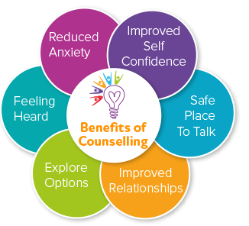

**Life style changes in Middle adulthood**

* Lifestyle can be defined as a way of living the things that a person or particular group of people usually do.Adopting a healthy and balanced lifestyle helps young adult to work efficiently and achieve their goal successfully as well as sustain a wellness state throughtout the middle adulthood old age. Adulthood should be counseled about the positive lifestyle changes needed to adopts and help them to cope with those changes.

**Lifestyle changes in middle adulthood**

* Physiological changes, hormonal and metabolic changes.
* Changing in nutritional pattern .
* Changes in role and responsibility.
* Rest and sleep.
* Sexuality.

Physiological changes

* + Wrinkled skin
  + Loose elastic skin with loss of skin turgor
  + Drier skin due to less production of sebum.
  + Loss of hair.
  + Decreased in sensory function.
  + Menopause in female etc.

**Emotional changes**

* Varying level of estrogen, progesterone and other hormonal changes in middle adulthood affect the mood like irritability, anger due to physical changes, depression, changes in sexual desire may occur.

**Changes in role and responsibilities**

* Middle age person is the sandwich generation. They have both responsibilities of children as well as aging parents. side by side they have occupational and also familiar and social responsibilities that may lead to physical and psychological exhaustion.

**Changing in the nutrition pattern:**

* BMI decreased along with basal energy requirement due to reduced physical activity and loss in functioning of protoplasm causes less demand for calories.
* Calories should be taken from carbohydrate is 45-60% ,from protein is 10-35% and from fat is 20-35%.
* High fiber diet should be provided to prevent constipation.

**Rest and sleep:**

* Most of middle aged person sleep about 7-8 hours without difficulties per day, which must be balanced with physical activity to maintain optimum function. Middle age awake several times during night in contrast to the young adult and duration of sleep is shorter.

**Sexuality :**

* Men need more time to get erection. In male, production of testesterone decreased and in female gradually decrease oestrogen and progesterone , wall of the vagina become less elastic, thinner and vagina shrinks causing painful intercourse for some women.

**Nursing Responsibility** **for lifestyle changes** :

* Patient can be educated about the following life style changes needed to be considered.
* Nutrition – healthy and balanced diet containing items from each of four main categories (carbohydrates, vitamins, fats and protein) to be taken daily, including folic acid
* Attaining and maintaining healthy weight for age and sex group ( Normal BMI: 18.5-24.9 kg/ m2)
* Getting 7-9 hours of sleep at night everyday.
* Avoid or limit the use of caffeinated beverages and alcohol.
* Perform physical exercise at least 30 minutes a day or 150 minutes a week including (stretching/ flexibility, weight bearing/ strength training, balance and endurance/ cardio exercises)
* Helping smokers quit and promoting smoke-free public places.
* Identifying the predisposing factors and risk behaviors and helping the client to modify or eliminate them.
* Maintaining a healthy and safe sexual life
* Practicing yoga, meditation and other recreational activities.
* Drink adequate water to maintained hydration.

**3.Screening**

It is defined as he presumptive identification of unrecognized disease in an apparently healthy, asymptomatic population by means of tests ,examinations or other procedures that can be applied rapidly and easily to the target population.

Most adolescents do not seek advice about preventing leading causes of

morbidity and mortality in their age group. So adult should be encouraged for

different types of screening which is essential for healthy life.

For eg-Pap smear for cervical cancer, X-ray for T.B, blood pressure for Hypertension etc. In this way ,disease or risk factors are being detected earlier allowing either for early treatment or for prevention, including limiting further spread transmission.

**Uses Of Screening**

-Case Detection

-Control of Disease

-Research Purpose

-educational Opportunities

1. Case Detection ( Prescriptive Screening)

-Defined as “ the presumptive identification of unrecognized disease, which doesn’t arise from a patients request.

1. Control of disease ( prospective Screening)

* People are examined for the benefit of others.
* Screening of immigrants from infectious diseases like ebola, tb and syphilis to protect the home population.
* Screening for HIV, STD etc.

1. Research purpose

* To known the history of many chronic diseases like cancer, HTN etc
* Screening may aids in obtaining more basic knowledge about the natural history of such diseases.

1. Educational opportunities

* Screening programs help in
* Acquisting of information of public health relevance.
* Providing opportunities for creating public awareness.
* For educating health professionals.

**Difference Between Screening Test and Diagnostic Test**

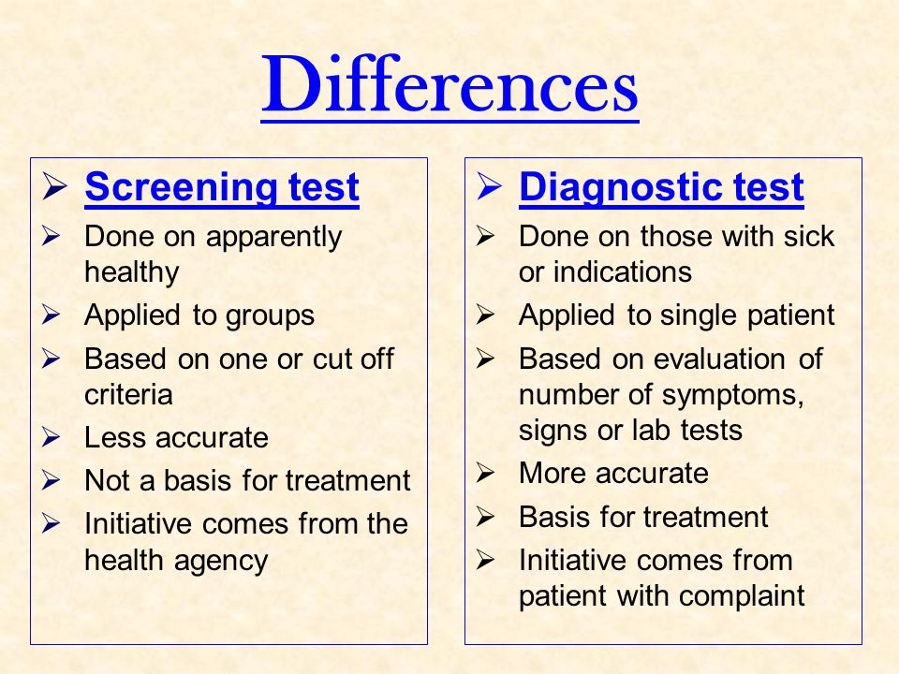

**Types Of Screening**

1. Mass Screening
2. High Risk / selective/ Targeted screening
3. Multipurpose screening
4. Multiphasic screening
5. **Mass Screening**

**-** Mass screening simply means the screening of a whole population or a sub group. Eg adults

Example- Mammography in women aged 40 years or less

-Colonoscopy for occult blood.

1. **High Risk Screening**

**-** It is applied selectively to high risk groups, the groups defined on the basis of epidemiological research.

Example-Screening for familiar cancers, HTN and DM.

Screening For cancer cervix in low social group.

Screening for HIV in risk group**.**

1. **Multi-Phasic Screening**

**-** It has been defined as the application of two or more screening tests in combination to a large number of people at one time than to carry out screening tests for single diseases.

- This Procedure may also include health questionnaire, clinical examination and a range of measurement and investigations.

Example-

DM- Fasting Blood sugar, Glucose Tolerance test

Sickle cell Anemia- Complete blood count , HB

Electrophoresis

1. **Multi-Purpose Screening**

**-** The screening of population by more than one test done simultaneously to detect more than one disease.

Eg- Screening of a pregnant women for VDRL, HIV, HBV by a serological test.

Different screening are performed in adult to monitor proper functioning of the body organs. And to detect any abnormal condition are given below:

**a. Blood pressure screening**

-Blood pressure should be checked every 1-2 years, If the systolic blood pressure is between120 and 139 or the diastolic pressure is between 80 and 89 mm of Hg ,then have it checked every year.

-If systolic blood pressure is greater than140 or the diastolic blood pressure is greater than 90, schedule an appointment with health care provider.

-If the person have Diabetes, kidney problems or certain other conditions they should check their blood pressure often.

b**. Cholesterol screening and heart disease prevention**

If patient age is 35 or years or older, check cholesterol, electrocardiography every 5 years.

If person have high cholesterol level, diabetes, heart disease or other certain other conditions check more often.

Some people should consider taking aspirin to prevent heart attacks, ask health care provider before starting aspirin because aspirin may increase the risk for bleeding.

**c.Diabetes screening**

Blood glucose every 1 to 3 years to diagnose prediabetes or type 2 diabetes more often if necessary.

-If the person is 45 years or older, they should be screened every 3 years..

-If you are overweight, ask health care provider if it’s necessary to be screened at a younger age.

-If the person’s blood pressure is above 135/80 mm of Hg or have other risk factors, health care provider may test blood sugar level for diabetes.

**d. Kidney function test**

Creatinine test at every 2 years of interval is recommended.

**e. Osteoporosis screening**

If the person is between ages 50 to 70 years and have risk factors for osteoporosis, they should discuss with health care provider.

-Risk factors can include long term steroid use, low body weight, smoking, heavy alcohol use, having a fracture after age 50 years or a family history of osteoporosis.

**f. Female: Breast, Uterus and cervix**

-Breast self examination monthly.

-Clinical breast examination at least every 2-3 years during the 20 and 30 and annually after age 40 years.

-Mammogram annually beginning at age 40 years.

-Pap smear test annually or every 2 years especially if history of genital warts, multiple sexual partners etc. After age 30, if three normal test in a row, testing may be done every 3 years.

-Cervical cancer testing every 3 years after beginning sexual intercourse or after 21 years of age.

**g. Male: scrotum, penis, prostate**

-Testicular examination monthly.

-Clinical examination if one testicle seems much larger or harder or if a lump is present.

-Prostate examination through digital rectal by professional exam and blood test for prostate-specific antigen(PSA).

**h.. Male and female :Skin**

* Self examination monthly after bath or shower to become familiar with general appearance of skin and pattern of spots, blemishes, color.

-Have someone else check top of head if bald or thin hair, back of neck, buttocks and thigh.

-Use mirror to complete observation if exam must be done completely by self.

**i. Thyroid screening**

-T3, T4 test is done at 3 years interval.

-This test is recommended to middle adult age adult, pre- menopausal and post -menopausal women.

**j. Colon cancer screening:**

-If the person is under age 50 years, they should be screened if they have a strong family history of colon cancer or polyps.

-Screening may also be considered if they have risk factors such as history of inflammatory bowel disease or polyps.

-If the age of a person is between the age of 50to 75 years, they should be screened for colorectal cancer. There are several screening tests available. Some common screening tests include:

a. A stool occult blood test is done every year.

b. Flexible sigmoidoscopy every 5 years along with a stool occult blood test every 3 years.

c. Colonoscopy every 10 years.

They may need colonoscopy more often if they have risk factors for colon cancer,such as:

* + Ulcerative colitis
  + A personal or family history of colorectal cancer.
  + A history of colorectaladenomas.

**k. Dental examination:**

Annual dental examination is recommended to detect and prevent dental carries and periodontal disease.

**l. Eye exam**

Have an eye exam every 2-4 years, ageing from 40-54 years and every 1-3 years ageing from 55-64 years.

**Reference**

* Murray.B. R. “Health promotion strategies through the life span”. (1985). (8th ed) USA:

Whitehouse book Ltd.

* Mandal G.N. (2013). *Textbook Of Adult Nursing.* Kathmandu.(5th ed).Makalu Publication

House .

* Gladding, S.T. ( 2004). Counseling: A Comprehensive Profession (5th edition). Upper

Saddle River, NJ: Merrill/Prentice Hall.

* Rai lalita. “Nursing concepts theories and principles”.(4th ed.).Akshav publication, Chhetrapati,Kathmandu.
* <https://patient.info/doctor/counselling-in-primary-care> Retrieved 2017/5/8
* <https://www.ncbi.nlm.nih.gov/pmc/articles/PMC1724179/>Retrieved 2017/5/8